Image Reference :

1. At.jpeg  
   <https://en.wikipedia.org/wiki/Aloo_tikki#/media/File:Aloo_Tikki_served_with_chutneys.jpg>
2. Bl.jpeg  
   <https://bakeitwithlove.com/blue-lagoon-cocktail/>
3. Burritos  
   https://www.shutterstock.com/image-photo/burritos-wraps-beef-vegetables-on-black-1088296088

Food Blog - HTML Live Lab 1

### Use Case:

There is a need to create a website for anyone who is a food lover. A foodie would like to share the experiences and reviews of various food items that the person has really enjoyed.

This website is a blog on different food items .

The assignments in this lab are divided in 5 sections starting from easy to difficult level taking you through the process of creating a website for writing blogs.

### Lab Name: Assignment 1

### Content Mapping: Basic Tags of HTML, HTML Attributes, HTML Elements

### Learning Pre-requisites:

- Tags: title, p, img, hr, heading, image attributes [ width and height],

### Env Needed:

VSCode, Google Chrome

### Asset Needed: Images

### Difficulty: Easy

### Duration: 10 Minutes

Input:

- Use HTML tags h1, title, p, img, hr, image attributes width and height to create website

Output:

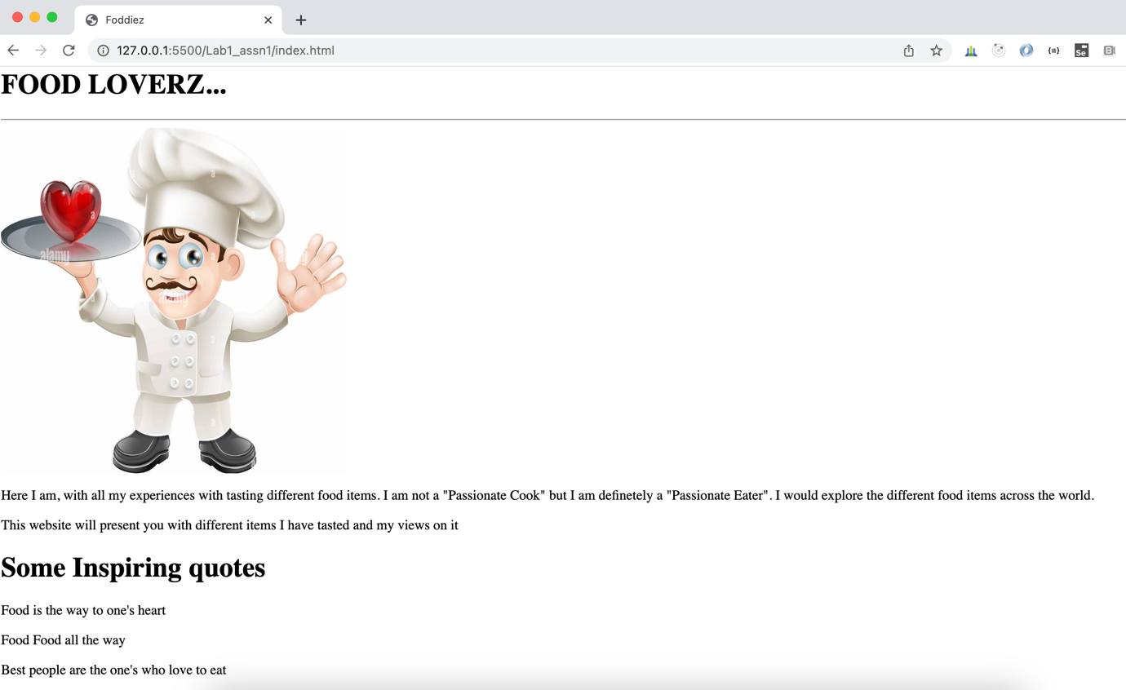

### Lab Name: Assignment 2

### Content Mapping: Basic Tags of HTML, HTML Attributes, HTML Elements

### Learning Pre-requisites:

- Tags: span, style(color and background color), div, br

### Env Needed:

VSCode, Google Chrome

### Asset Needed: Images

### Difficulty: Easy

### Duration: 10 Minutes

Input:

- Modify the previous webpage for adding styles and span tag to decorate certain part of text with different color. Wrap all the quotes inside a single div and apply style to the div, not the p tags individually. Break the line in the first paragraph as shown below

Output –

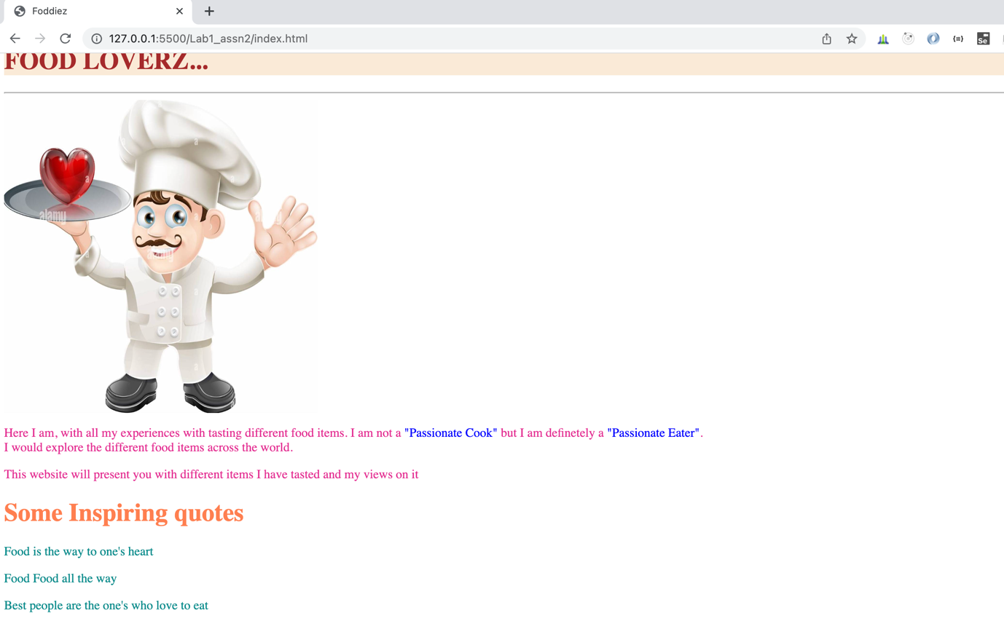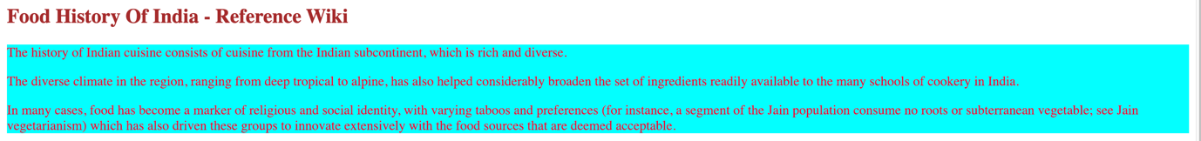

NOTE:

History is taken from wiki : <https://en.wikipedia.org/wiki/History_of_Indian_cuisine>

### Lab Name: Assignment 3

### Content Mapping: Basic Tags of HTML, HTML Attributes, HTML Elements, HTML Links

### Learning Pre-requisites:

- Tags: span, style(font), div, br, a and adding pages

### Env Needed:

VSCode, Google Chrome

### Asset Needed: Images

### Difficulty: Medium

### Duration: 20 Minutes

Input:

- Modify the previous webpage for adding links as shown in the image below.

- Create 3 different pages contact.html, Indian.html, Mexican.html. The page output is as shown in the image below. Do change the font of heading on the 3 pages

Output –

Index.html

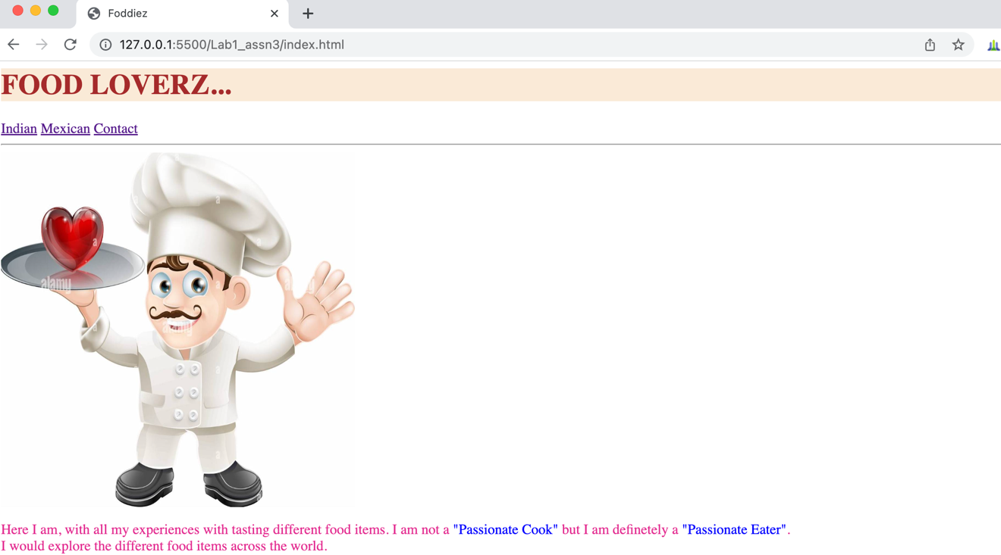

Mexican.html

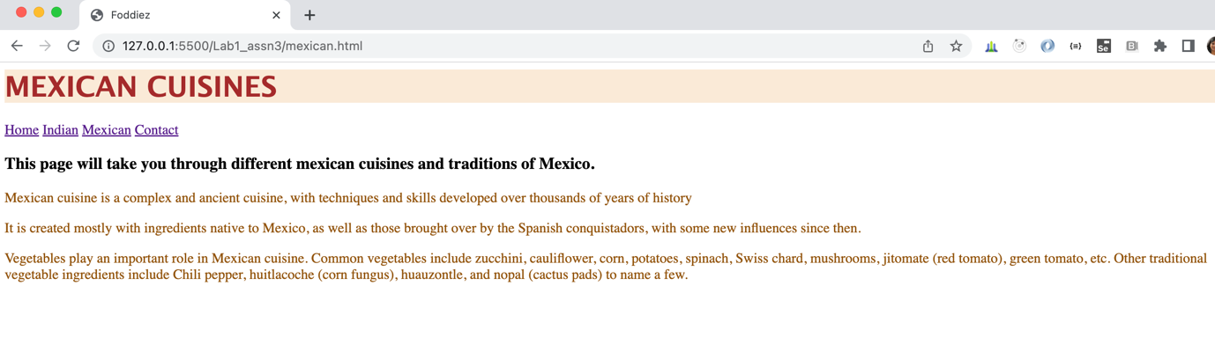

Contact.html

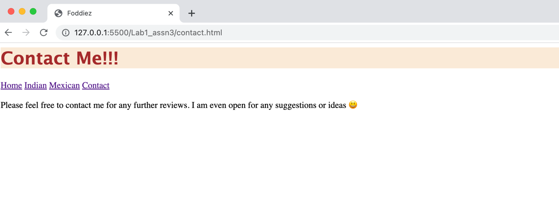

Indian.html

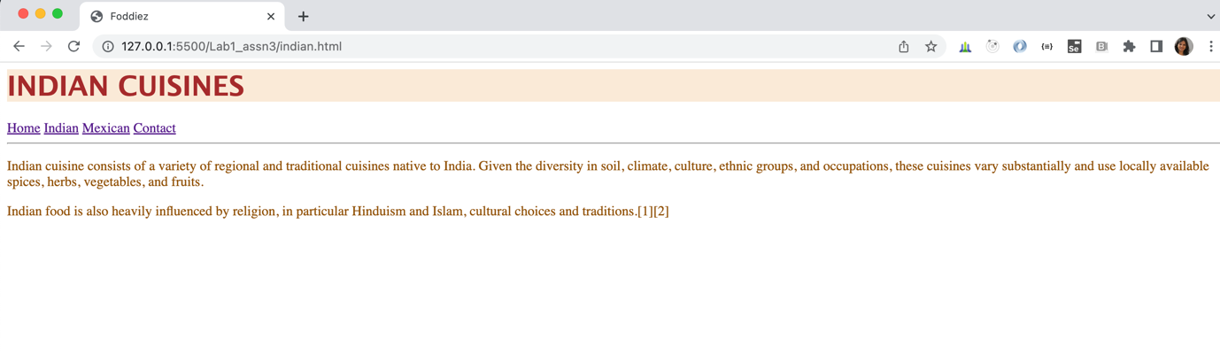

### Lab Name: Assignment 4

### Content Mapping: Basic Tags of HTML, HTML Attributes, HTML Elements, Links Colors and Bookmarks

### Learning Pre-requisites:

- Tags: span, style(font), div, br, a and adding pages, font size, link colors, link reference using #

### Env Needed:

VSCode, Google Chrome

### Asset Needed: Images

### Difficulty: Medium

### Duration: 20 Minutes

Input:

- Modify the previous index page and the contact page should open in a new tab.

- Change the color of links to brown and increase the font size of the link text in all the html pages

- Change Indian.html page to look as shown in the diagram: When clicked on particular food item should take to that part of the page. When clicked on ^ should take to the top of the page

Output –

Links updated with colors and fonts in all the pages

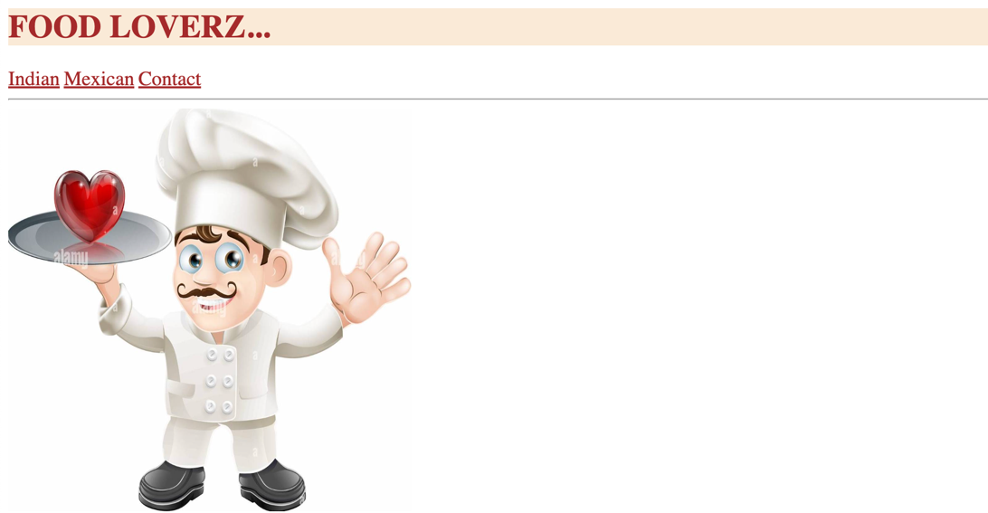

Indian.html

Modify the links to green colors.

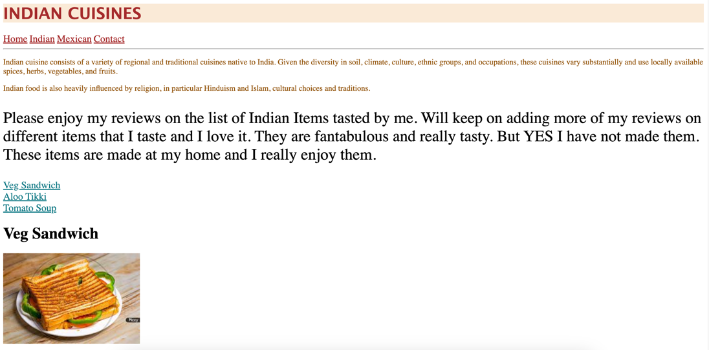

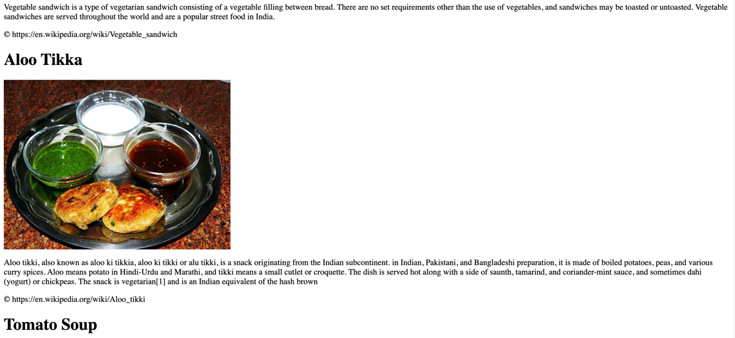

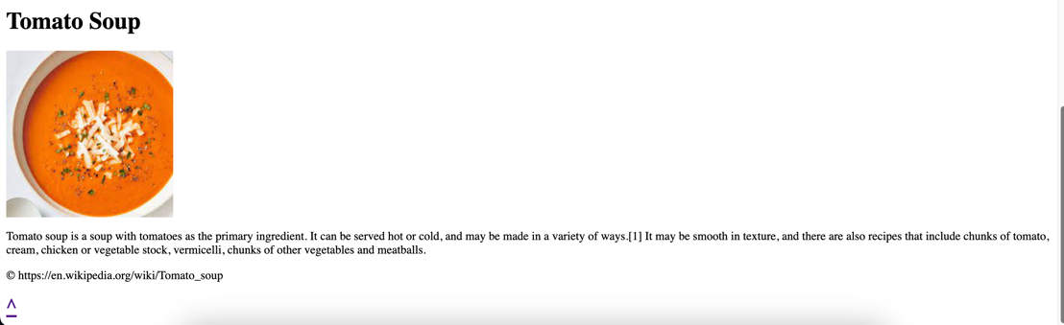

### Lab Name: Assignment 5

### Content Mapping: Basic Tags of HTML, HTML Attributes, HTML Elements, Links Colors and Bookmarks

### Learning Pre-requisites:

- Tags: span, style(font), div, br, a and adding pages, font size, link colors, link reference using #

### Env Needed:

VSCode , Google Chrome

### Asset Needed: Images

### Difficulty: Difficult

### Duration: 30 Minutes

Input:

- Modify the previous mexican page as shown below with link colors and the items added. When clicked on particular food item should take to that part of the page. When clicked on ^ should take to the top of the page

- Modify all the copyright text and wrap around an anchor link as shown in Output 2. below. When clicked the corresponding wiki page or the details page should open in a new tab. Do this for all Indian and Mexican pages

- Add one more page drinks.html. Add links in all the pages to go to drinks.html and display some of your favorite drinks same as shown for Indian and Mexican pages. Output as shown in 3. below

Output –

1. Mexican.html

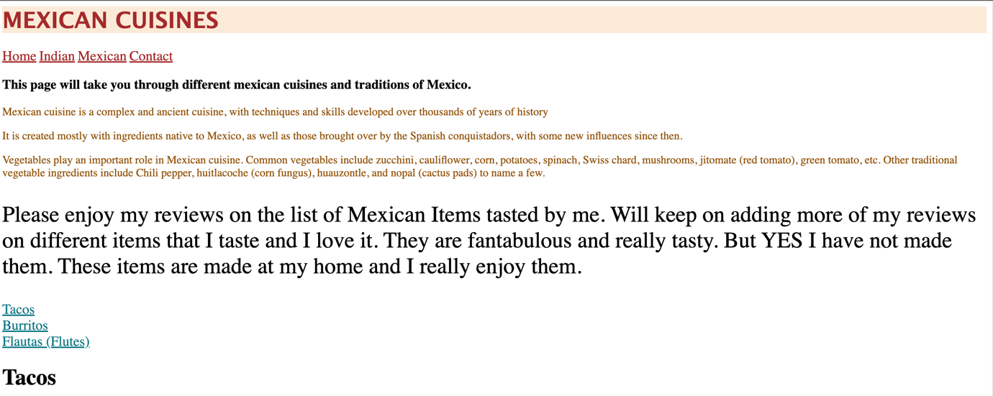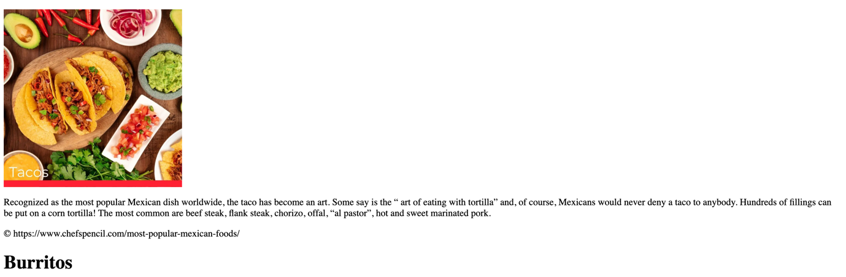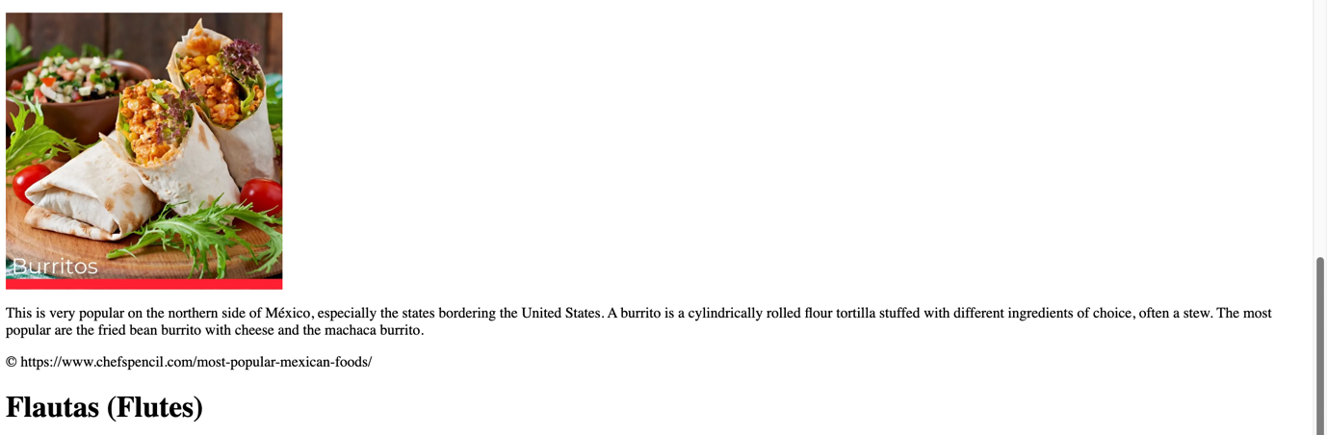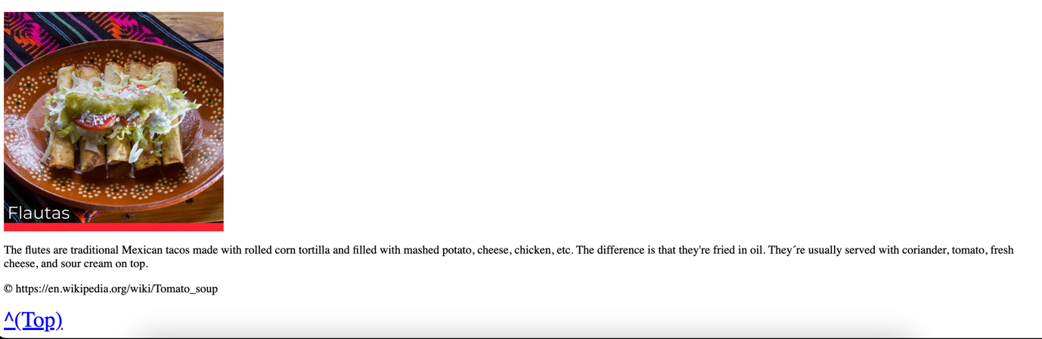

1. Copyright text around the link

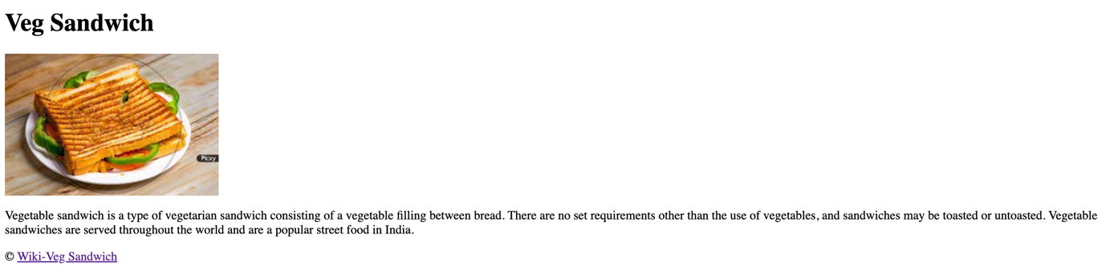

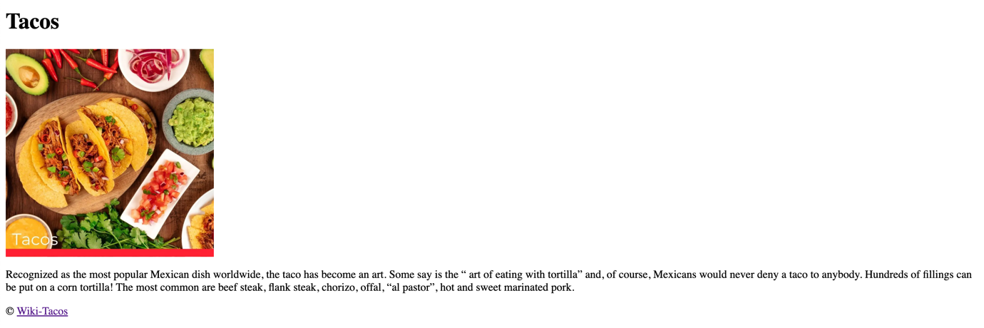

1. Drinks.html  
     
   